PROJECT COMPONENT LIST
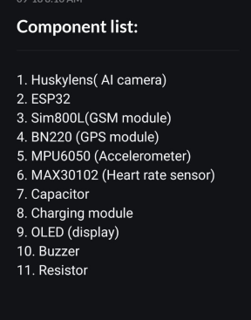

MAINTAINENCE EQUIPMENT LIST:
1. Soldering iron
2. ⁠Multimeter
3. ⁠Screw driver box
4. ⁠Jumper wires
5. ⁠Breadboard
6. ⁠Sponge
7. ⁠Resin/flux
8. ⁠Lead
9. ⁠Soldering iron stand

